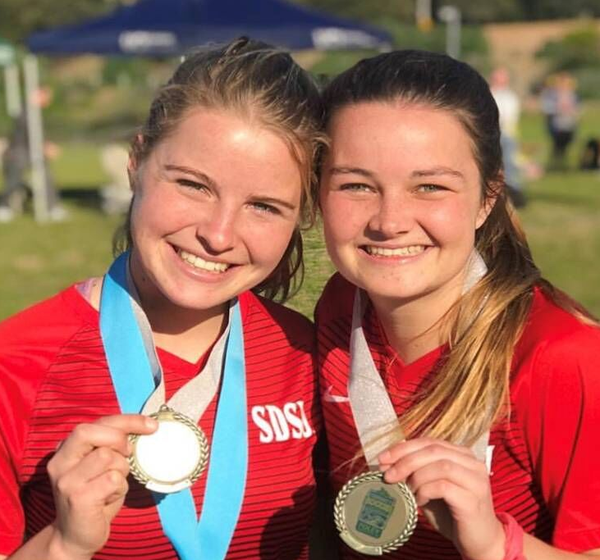
Summer Slough (on the left in photo)

Summer Slough is one of our continuing scholarships recipients for 2019. Her statement in her application sums it all up!
My name is Summer Slough and I just finished my second year at San Diego State University. I am a marketing major, and personality and social psychology minor. I am beginning to find my career interests and look forward to expanding my horizons with my education. I am currently playing on the SDSU Women’s Club Soccer team and we have been doing amazing! We won league last year and just won the NIRSA Open Cup tournament in Foley, Alabama last semester! I look forward to continuing my education and my love for soccer and want to thank the Garon family for all their love and support.

Summer sent the Garon’s the SDSU Women's Club Soccer schedule, so they could attend sometime. They did and said they were, “GREAT! So good to see Summer.” The photo for this year is of her and a teammate at their tournament championship!

