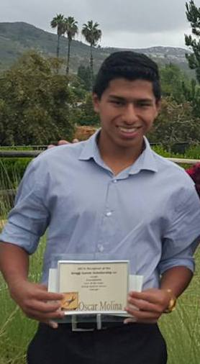

Oscar Molina - graduated from Mission Vista High School in Oceanside and played club soccer for Fallbrook Villa. From the age of 11, Oscar left his house each day to work cleaning houses with his mother, a poor immigrant from Guatemala. It was hard work . .. gave him motivation to make a different life for himself. He transferred his work ethic to his studies and found that his motivation let him to take rigorous taken honors and AP courses, earning a 4.37 GPA. He was also active in campus clubs and volunteer activities.

In his own words: "My mom was left with no choice but to work in a low paying, labor intensive job to provide a better future for me. She inspired me to work hard to reach my full potential. . .my ultimate goal is to inspire other students who are in similar situations by sharing my story. Through the degree I pursue in college, I am motivated to positively impact low socioeconomic communities by cultivating college-bound mindsets among younger generations.

So, now, Oscar is looking forward to attending UCLA in the fall. . .the first generation in his family to attend college!

