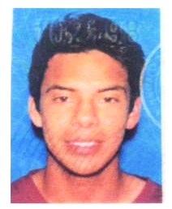

Jesus Olea Estevez - graduated from San Marcos H.S. and played for Rancho Santa Fe Attack. Jesus (Chuy) wrote that he loved soccer so much. . he would want to sleep in new cleats and snuggle with his soccer ball. He was able to make his high school team as a freshman and early on had several universities looking at him. However, he had two knee injuries in high school, which kept him out his final two seasons. He wants to rehab and play again. . but this has made him realize that there are always and setbacks in life, and now he is looking at going on to college. He is the first generation in his family to attend college.

