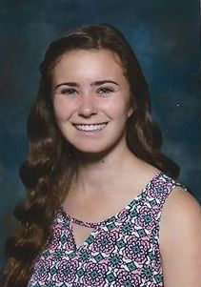

Carisa Hilton - graduated from Mission Hills High School. She also played for FC Heat in Escondido. Carisa started her essay with "I love soccer!". She is a volunteer coach for elementary students at "Summer Splash" a community outreach camp at Mission Hills Church. She will be attending the College of St. Benedict in St. Joseph, MN to pursue a degree in Food Science and Nutrition and hopes to try out for their soccer team. She quoted Mia Hamm, "I am a member of a team, and I rely on the team. I defer to it and sacrifice for it, because the team, not the individual, is the ultimate champion" .

