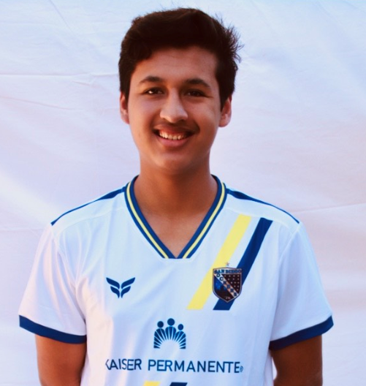

Allan Hernandez - 2021 Scholarship Recipient

Allan has been dedicated soccer player with a love for the “beautiful game”. He has worked hard to show passion and appreciation for the game throughout his youth soccer career. Allan’s loyalty is evident as he has played for the same youth club for his entire career, the Cardiff Mustangs FC, stretching back to the time when there were only three teams. He saw his club expand and become the Cardiff Sockers, an official youth affiliate of our very own San Diego Sockers now consisting of over thirty teams!

He believes soccer has taught him life lessons and character traits, including leadership and professionalism, which he will continue to apply to in life. His love of the game shines through - as he stated that he knows he should enjoy every minute he is on the field, "…because I understand I cannot play this game forever, eventually my time will come to an end".

Allan has also been both a strong student as well as a volunteer. He has taken a little over a dozen AP courses while maintaining over a 3.5 GPA. In addition, he has accumulated over 100 community service hours as the Mustang Mentors Student Coordinator. Mustang Mentors is a program that allows high school students to counsel and enhance a love for learning to elementary school students. Through this program, he has been motivated to pursue a future to help others work towards their goals and ambitions. His hope is to create a small business that would help young soccer players succeed in continuing to college and meet their goals. To that end, Allan has decided to attend Beloit College in southern Wisconsin where he will play soccer while majoring in Business economics.

