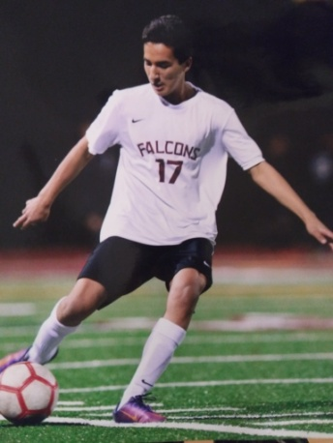

AJ (Abel) Castellanos

Join me in congratulating the next Gregg's Goals 2020 scholarship winner: AJ (Abel) Castellanos from Torrey Pines High School. Unfortunately, AJ's soccer career was hampered by injury. In his sophomore year in high school, he suffered a severe concussion while playing that put him out of sports for the entire year. Once he was cleared, he began to work to get back into shape - spending countless hours training. As a result, he returned to his high school team by his senior year and they won CIF in their division. While he has not committed to a university yet, he has a high GPA out of high school and plans to attend a four year college and pursue a degree in kinesiology with the goal of becoming a physical therapist.

AJ wrote that soccer taught him great life lessons about community, perseverance, work ethic, team work and "even friendship". He is described by his coaches as being a team leader, respectful, hard working kid with maturity and self control. IT was also noted that he is a role model for younger players and gave of his time to teach other kids how to play. We are proud to be able to present AJ with this scholarship, as he continues to pursue his goals!

