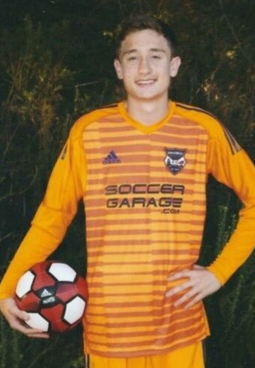
Jacob exemplifies the characteristics needed for the Gregg Garon Scholarship. He loved soccer from when he first started playing in Wisconsin and specialized in goalkeeping in 2009 on his Poway Vaqueros team. He has many on field accomplishments including playing for the San Diego Surf Soccer Club USDA team, and traveling to play soccer in Spain and Portugal. He also received the honor of winning the 2018 coaches award at San Diego Soccer Club. More importantly, he has demonstrated leadership and “giving back.” He was the youth ambassador for a nonprofit organization, “Wish a Smile,” with the San Diego Football Center, volunteering time to pass his soccer knowledge onto the next wave of soccer players. He states working with the training center helped him to learn the values of accountability, community, humility and integrity. He will be continuing DII soccer at Humboldt State University majoring in Business Administration. He plans to get a Master’s degree and work in Sports Management.

