2018 Scholarship Recipients:
Kendall Kolb
Kendall has overcome many setbacks in her young life, but learned to persevere and "take control" of her own life, as she stated it. She found that as she faced the difficulties in her life, soccer was her escape. No matter how bad life was, when she got on the soccer field, she was happy. In addition, she studied hard and maintained at high GPA at Poway High School. She has had multiple leadership roles in high school, from being President of AVID her senior year, President of Peer Counseling for two years and the President of the Student Advisory Board her senior year. She would like to major in business in college.

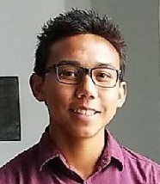
Taylor DeGuzman
Taylor is a student at Del Norte High School, where he has a 3.95 GPA, and played club soccer most recently for Poway Vaqueros. He started soccer at age 4 and has played for 14 years. Taylor notes all the positive aspects of soccer, from the brotherhood with teammates, loyalty and learning to put in the hard work needed to win. He also learned valuable life lessons from the negatives he encountered on a past club team, where some teammates were putting other “pursuits" ahead of their commitment to the team. One of Taylor's current coaches describes him as quiet and respectful off the field, but "like a lion" when he plays. Taylor is currently planning on attending a 4-year college and continuing to play soccer.
Lennon Yorke
Lennon is a senior at Mission Vista High School and plays for Escondido FC Heat. Lennon has always been the captain on his soccer teams, although adding he has never been the best player on any team he’s been on. Lennon he has been playing soccer for as long as he can remember. His best memory is from an international trip with his competitive team to Dalian, China. While none of their three games had "favorable results", he found the experience forged the bonds of brotherhood with his teammates and increased his love for the game. Lennon’s plans include studying human physiology at Boston University with the eventual goal of being a naval trauma surgeon.

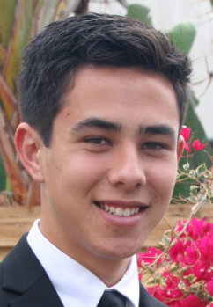
Thomas Goya
Thomas started playing soccer at the age of 4 and has played for 14 years. He currently plays for the Oceanside Breakers and Mission Vista High School. He is an assistant coach for a girls under 10 recreational team and a referee. His coaches praise him as one of the hardest workers on the team, and serves as a team leader, because of his positive attitude. Thomas maintained a high GPA in high school and plans to attend the University of Colorado, Colorado Springs and major in Sports Management, with an emphasis on soccer. His goal is to be a general manager of a professional soccer club. While he is at UCCS, he hopes to "walk on" to the soccer team.

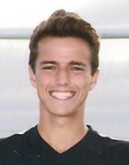
Brandon Dee
Brandon Dee is a senior at Mission Vista High School in Oceanside, with a 4.4 GPA. His goals are to study Mechanical Engineering in college. He would eventually like to be an Automotive Engineer with a focus on sustainable design. Brandon started playing soccer at age 5 in his hometown club in Germany. It was there he became committed to "the beautiful game." He moved to California at age 11 and his family couldn't afford the club soccer fees. So, Brandon found a number of ways to get his fees reduced from picking up trash at the fields to selling snow cones. At age 15, he became a referee to help pay. He is currently the captain of both his high school and club teams and is a volunteer assistant coach to an 11 year old boys’ team. Brandon is both a determined young manand a great role model!

